CHAPTER ONE: INTRODUCTION
1.0 Background
The rapid growth of wireless communication technologies and user demand for high-speed, low-latency services has driven the evolution of 5G networks. These networks aim to support enhanced mobile broadband, massive machine-type communications, and ultra-reliable low-latency communications. To meet these requirements, 5G adopts dense deployments of small cells, massive MIMO, and centralized processing architectures like Cloud Radio Access Networks (C-RAN).
C-RAN decouples the baseband units (BBUs) from the remote radio heads (RRHs) and centralizes baseband processing, enabling more flexible and efficient resource management. However, this architecture introduces new challenges, especially in energy efficiency. The continuous operation of RRHs and the need for high-capacity front haul links significantly increase the energy footprint of the network.
With increasing global focus on sustainability and operational cost reduction, energy-efficient strategies are essential. Traditional rule-based and heuristic methods for resource allocation lack adaptability in dynamic environments. Recent advances in Machine learning and Artificial Intelligence (AI), particularly Deep Reinforcement Learning (DRL), offer promising solutions for intelligent, adaptive resource management in complex network scenarios like 5G C-RAN.
1.1 Problem Statement
While C-RAN improves scalability and performance in 5G, it also leads to high energy consumption due to continuous RRH activity and centralized processing. Static and heuristic energy-saving approaches fail to dynamically adapt to varying traffic loads and channel conditions. There is a need for a robust, intelligent control system that can optimize energy usage without compromising user Quality of Service (QoS). Deep Reinforcement Learning, with its ability to learn from interaction and make real-time decisions, presents a promising avenue for optimizing energy efficiency in such environments.
1.2 Objectives
The main objective of this research is to develop a DRL-based framework for optimizing energy efficiency in 5G C-RAN. The specific objectives are:
- To model the energy consumption and traffic behavior of a 5G C-RAN system.
- To design a DRL agent capable of making dynamic decisions on RRH activation and resource allocation.
- To evaluate the performance of the DRL-based strategy against conventional methods in terms of energy savings, throughput, and latency.
1.3 Research Questions
- How can DRL be applied to optimize RRH control and resource allocation in 5G C-RAN?
- What are the trade-offs between energy efficiency and QoS in the proposed DRL framework?
- How does the DRL-based method compare to traditional heuristic approaches?

1.4 Significance of the Study
This study contributes to the field of intelligent wireless network management by:
- Proposing an adaptive, AI-driven solution for real-time energy efficiency.
- Reducing the operational cost of 5G deployments through smarter resource use.
- Offering a framework that can be extended to future 6G networks and other energy-critical applications.
1.5 Scope of the Study
This research focuses on downlink transmission in a simulated 5G C-RAN environment. It considers RRH activation and bandwidth allocation as optimization targets. The study uses a single DRL agent in a centralized setting and evaluates performance through simulation using standard 5G parameters. It does not cover uplink traffic, hardware-specific energy profiling, or multi-agent interactions.

CHAPTER TWO: LITERATURE REVIEW
2.0 Introduction
The Cloud-RAN (C-RAN) concept was first proposed by IBM in 2010 [11*], and it was called
Wireless Network Cloud architecture, and later described in detail by China Mobile [25*], it was then called Cloud infrastructures RAN. The Cloud-Radio Access Network (C-RAN) architecture was intended to provide energy efficiency, scalability, and mobility and interference management as well as decrease the cost of the Radio Access Network (RAN). However, these benefits came with the drawback of a very capacity demanding and latency strict front haul network.
Recently, Mobile data traffic has increased exponentially due to a growing number of smart devices and their applications in the network. By 2023, Cisco expects that up to 71% of the global population will have mobile connectivity, and the total number of mobile subscribers will grow to 5.7 billion [1]. As a result, mobile network operators have to improve the coverage and capacity of existing radio access networks to catch this exponential growth in data demand [2] and maintain a satisfying level of quality of service (QoS) for end-users. Towards facing these challenges, many potential solutions have been discussed. For example, building and operating new RANS or even upgrading the old ones and applying the small-cell networks [3].Although these solutions have increased network performance in coverage and capacity and decreased network losses, they have unwanted effects on the network power consumption [2].
The main part of power consumption in the traditional cellular network is Base Stations (BSs) that will lead to an increased Operating Expenditure (OPEX) [67, 19]. C-RAN architecture is presented as one of the 5G solutions for saving energy, simplifying the management and control of mobile networks [5, 68]. The most significant aspect of C-RAN to provide data requirements is the Radio Access Network (RAN) [8, 69]. It is anticipated that the RAN, as represented by the microwave back-haul link, cannot meet the demand for increasing data rates. Hence, high capacity optical fire is proposed to replace the microwave backhaul to these needs. The optical fire is used as a fronthaul to connect the BBUs from the BBU pool to the RRHs. The distance between an RRH and a BBU pool is up to 40 km. The distance limitation is due to the propagation delay of fire and signal processing in BBU [8].Recently, virtualization technology has been used in the BBU pool to decrease costs and power consumption. Generally, it consists of two parts, physical servers that work with a set of hardware components, and a software platform that is applied by an operating system. The virtualization technology has many benefits in C-RAN architecture, such as reducing costs, minimizing investment capital, reducing power consumptions well as providing more reliability and flexibility in utilizing the server/network resource [8].
2.1 Cloud Radio Access Network Architecture
2.1.0 C-RAN Model
In the C-RAN architecture, the baseband processing, traditionally performed locally at each BS, is aggregated and performed centrally at a cloud computing center. This is enabled by high-speed connections, referred to as fronthaul links, between the BSs and the cloud. Such centralized signal processing allows for the possibility of interference cancellation and interference pre-compensation across all the users in the uplink and downlink, respectively. The C-RAN architecture thus facilitates the implementation of network multiple-input multiple-output (network MIMO) [12], also known as coordinated multi-point (CoMP) or multicellular processing (MCP) in the literature [6, 26]. The network topology of one central processor (CP) coordinating a cluster of BSs serving users over a certain geographic area as illustrated in Fig. 2.1

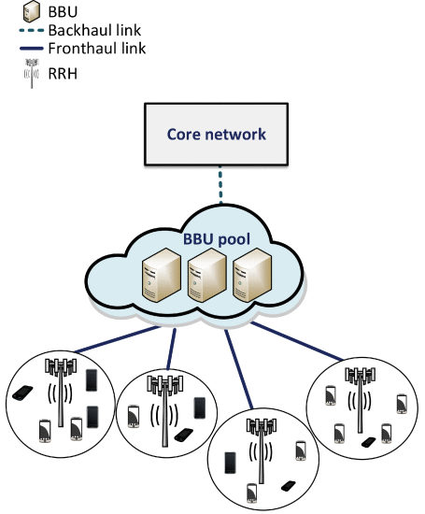

Figure 2.1 C-RAN System Model

The BSs in the C-RAN architecture are also termed remote radio heads (RRHs) as their functionality is often restricted to transmission and reception of radio signals. These RRHs are managed by the cloud-computing based CP, called baseband units (BBU) that communicates with RRHs via fronthaul links. The fronthaul connections can be dedicated fiber optic cables, or they can be wireless links. The Interconnection and split function between the BBU and RRH depend on type of the network deployment. The distance between an RRH and a BBU pool is up to 40 km [28], distance limitation is coming from the propagation delay of fire and processing signal in BBU.

The Centralized architecture
Largely, there are three different types of C-RAN architectures according to the split function options of base band processing unit between RRHs and BBU pool. There are full centralization, partial centralization and hybrid centralization. This section shows these three types in detail.
Full Centralization: In this architecture type, the baseband processing functions (i.e., physical layer, the Medium Access Control (MAC) and the network layer) move to the BBU pool. In this case, the BBU demonstrates all managing and processing functions of the traditional BS. This architecture makes the system simpler and clear in the context of maintenance and operation, as well as it has capabilities to support multi-standards in the system. However, the RRH deals with up/down conversions, filtering, amplification of RF signals, and interface adaptions [21]. In general, this architecture suffers from a high burden on fronthaul.
Partial Centralization: In this structure, the RRH is responsible for the baseband processing that related to RF function. However, BBU is responsible for baseband processing that related to all functions of layer one and the upper layer. This structure reduces the RRH-BBU overhead and burden of fronthaul as shown in [6]. The structure of this type is shown in Fig. 2.6
Hybrid Centralization: Some functions of layer one such as the user specific functions and the cell-specific signal processing are removed from BBU to a separate unit. This unit may be part of the BBU pool or not [6]. This architecture can be as a special case of full centralization that has some advantages such as reducing energy consumption in BBUs. The structure of this type is shown in Fig. 2.6

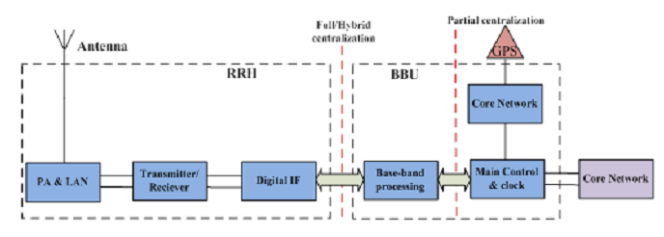

Figure 2.2

The fronthaul architecture
There are three types of optical fiber fronthaul networks: Time-Wavelength Division Multiplexing PON (TWDM-PON), Ethernet PON (EPON) and Active Optical Network (AON) [63].
TWDM-PON C-RAN architecture
TWDM-PON can be defied as a combination of Time Division Multiplexing (TDM) and Wavelength Division Multiplexing (WDM) technology, as shown in Fig. 3.3 [83]. In this architecture, the ONUs are located near to the RRHs and connected to the OLT through optical fibre located in the BBU pool. ONUs can share the same wavelength as the OLT, for which every wavelength is served by a Line Card (LC) (i.e. optical transceiver). Therefore, one LC can serve several ONUs at different sites, which leads to energy saving as demonstrated in [84].
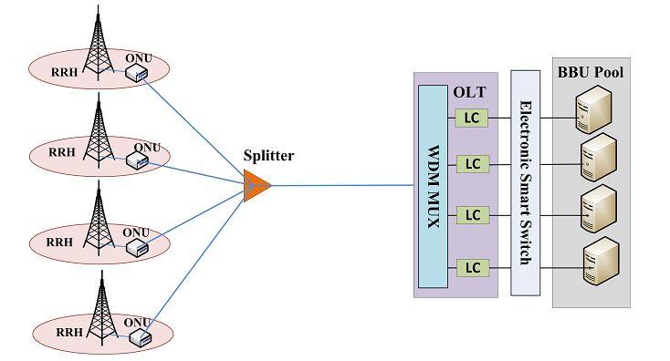
Figure 2.3

EPON C-RAN fronthaul architecture
The EPON fronthaul network does not use the WDM, which means the RRH (or number of RRHs) is using a splitter server with single wavelength, as shown in Fig. 3.4. This type is demonstrated in [76] and is explained as Point to Point (PtP) in [63].

AON C-RAN architecture
In an AON, the ONUs are connected to a Remote Node (RN) switch (e.g. in a street cabinet, in a building close to the RRHs or at an RRH site representing a master of a number of slave RRHs), which is in turn connected to a BBU pool switch, as shown in Fig. 3.5. Generally, the proposed RRHs are small, so they can be placed on poles or the rooftops of buildings [8]. Hence, this architecture is useful for application in FTTH networks.
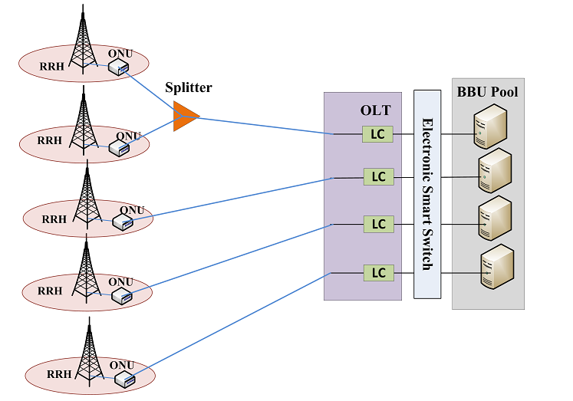
Figure 2.4

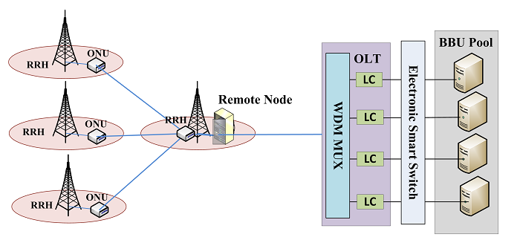

Figure 2.5
2.2 Key advantages of cloud radio access network
Cloud radio access network (C-RAN) architecture offers two key advantages as compared to traditional radio access network (RAN) from physical-layer transmission point of view. First, the centralization and virtualization of RAN allow coordination of base-stations (BSs) across a large geographic area, thereby enabling coordinated physical-layer resource allocation across the BSs. The physical layer resources here refer to frequency, time, and spatial dimensions that can be utilized by radio transmission. Second and more importantly, the C-RAN architecture also opens up the possibility of joint transmission and joint reception of user signals across multiple BSs, thereby fundamentally addressing the issue of inter-cell interference. As interference is the main bottleneck in modern densely deployed wireless networks, the C-RAN architecture offers significant advantage in that it provides the possibility of interference mitigation leading to performance enhancement without the need for additional site and bandwidth acquisition.

2.3 Deep Reinforcement Learning
This provides a technical and algorithmic framework for applying Deep Deterministic Policy Gradient (DDPG) to optimize Energy Efficiency (EE) in Cloud Radio Access Networks (C-RAN). DDPG is particularly useful for this task because, unlike standard Q-learning, it is designed to handle continuous action spaces, such as the fine-grained adjustment of transmit power levels for Remote Radio Heads (RRHs)(1)(2)
1. Architecting the DDPG Agent for C-RAN
The sources define DDPG as an Actor-Critic hybrid algorithm that combines the stability of value-based methods (like DQN) with the flexibility of policy gradients (1).
- The Actor (πθ​): In a C-RAN context, the Actor network maps the current network state (e.g., traffic demand, channel state information) to a deterministic action—specifically, a precise transmit power value or a resource block allocation (1).
- The Critic (Qϕ): The Critic network estimates the value of these actions by calculating an action-value function (1). It evaluates whether the power levels chosen by the Actor actually maximize the network's long-term energy efficiency while maintaining Quality of Service (QoS)(2)
2. Modeling the Energy Efficiency Environment
To use DDPG, the network must be modeled as a Markov Decision Process (MDP), which the sources describe as the "mathematical core" for RL problems (1)(2).
- State Space: The "state" includes high-dimensional sensory inputs from the RRHs, such as interference maps and user capacity requirements (2).
- Action Space: Because DDPG handles continuous variables, the agent can avoid the "coarse discretization" required by classic Q-learning, allowing for more precise power control that eliminates energy waste (1)(2).
- Reward Function: The goal of "Green Communications" is implemented through a reward function that balances Energy Efficiency (bits per Joule) against penalties for failing to meet Signal-to-Interference-plus-Noise Ratio (SINR) targets (2)(3).
3. Ensuring Training Stability and Exploration
One of the primary challenges in C-RAN is the highly dynamic and unpredictable nature of wireless channels (2). The sources provide specific DDPG mechanisms to address this:
- Experience Replay: The sources describe the use of a Replay Buffer (D) to store previous network states and actions (1)(2). Randomly sampling from this buffer breaks the temporal correlations in network traffic data, which is essential for stable neural network training (1).
- Target Networks: DDPG uses target networks that are several steps behind the main networks to act as a "stable anchor" (2). This prevents the C-RAN agent from overreacting to short-term channel fluctuations (1)(2).
- Gaussian Noise for Exploration: Since the Actor is deterministic, the sources suggest adding noise to the chosen actions during training (1). This forces the agent to explore different power-saving configurations (like cell sleep modes) that it might otherwise ignore (1).
4. Algorithmic Optimization and Distributed Processing
- Gradient Descent: The sources explain the use of Stochastic Gradient Descent (SGD) and Adam optimizers to iteratively update the parameters (θ and ϕ) of the DDPG agent toward the local minimum of the loss function(4)(1).
- Distributed Computing: For large-scale C-RAN BBU pools, the sources discuss distributed frameworks like MapReduce, which can be utilized to process the "massive-scale data" generated by 5G/6G sensors during the RL training loop (4).
By following the DDPG pseudocode provided in the sources, a developer can implement an agent that select actions to minimize the following
Critic loss: L(ϕ) =21​E[(r+γQϕ​(s′,πθ​(s′))−Qϕ​(s,a))²]
This mathematical objective ensures the network learns to consume only the energy strictly necessary to fulfill traffic demands.

2.4 Related works
The transition from traditional Radio Access Networks to Cloud Radio Access Network (C-RAN) architectures is driven by the need to support massive data traffic and diverse Quality of Service (QoS) requirements in 5G and beyond(1)(2). C-RAN fundamentally decouples the Baseband Unit (BBU) from the Remote Radio Head (RRH), centralizing processing in a BBU pool while distributing low-cost RRHs (1)(2)(3). This centralization facilitates coordinated resource allocation across large geographic areas and enables joint transmission techniques to mitigate inter-cell interference (3)(4)(5). However, the increasing complexity, high dimensionality, and dynamic nature of these networks render traditional model-based optimization methods—such as convex optimization and heuristic algorithms—often insufficient or computationally too expensive for real-time applications (3)(6).
A dominant theme in the literature is "Green Communications," focusing on optimizing Energy Efficiency (EE) within the RAN, which accounts for a significant portion of total network energy consumption, with estimates ranging from 57% to over 80% (3)(7)(8). To address this, researchers utilize Deep Reinforcement Learning (DRL) to manage cell sleep modes, intelligently switching RRHs between active and sleep states based on fluctuating user demands(2)(6)(8)(9). Beyond energy, Dynamic Resource Allocation (RA) remains a core pillar, encompassing the joint optimization of transmit power, beamforming weights, and user association to satisfy stringent 5G performance targets (2)(6)(7). Furthermore, network slicing has emerged as a vital theme, using DRL to logically partition physical infrastructure into virtual slices tailored for specific service types like URLLC (latency-critical), eMBB (bandwidth-intensive), and mMTC (massive connectivity) (7)(10).
Traditional methods provide stable, closed-form expressions but require perfect, prior system knowledge that is often unavailable in dynamic 5G environments (2). Conversely, model-free DRL learns optimal policies through direct interaction with the environment, though it faces challenges regarding convergence and explainability (2)(6)(8). Centralized BBU pools allow for global network visibility and optimal joint processing, yet they introduce significant signaling overhead and latency constraints on the fronthaul (1)(2)(6)(11). Distributed edge-based agents are proposed to reduce this burden, though coordinating them introduces new complexities (1)(10). There is a technical debate concerning the use of standard Deep Q-Networks (DQN). Critics argue that DQN often suffers from Q-value overestimation, leading to sub-optimal policies, and advocate for enhanced variants like Double DQN (to decouple action selection from evaluation) and Dueling DQN (to better prioritize state importance) (8)(2).
Most current studies assume perfect Channel State Information (CSI), whereas real-world networks operate under high levels of uncertainty and propagation noise (2). As networks densify, the state-action space for RL agents grows exponentially, making finding a global optimum computationally demanding and prone to converging on local optima (2). Existing DRL frameworks often neglect the massive signaling burden placed on the network when users must continuously report state information to the cloud (2)(5). Authors suggest exploring hybrid models, such as combining RL with Generative Adversarial Networks (GANs) to reach global optima or using Deep Deterministic Policy Gradient (DDPG) for continuous action spaces like fine-grained power control (2)(5)(10). While Virtual Machines are well-studied, there is a lack of detailed power modeling for containers and microservices, which are foundational to the modern Telco Cloud (1)(12).

CHAPTER THREE: SYSTEM MODEL AND PROBLEM FORMULATION
3.0 Introduction
This chapter presents the architecture of the 5G Cloud Radio Access Network (C-RAN) considered in this study and formulates the energy efficiency optimization problem by providing an optimization framework for cooperative beamforming and resource allocation in C-RANs. The chapter begins by identifying frequency, time, and spatial resources in wireless cellular networks, and defining the overall spectrum allocation, scheduling, and beamforming problem in a cooperative network. The chapter then provides a network system model for the C-RAN architecture, and illustrates typical network objective functions and constraints for network utility maximization.
Cloud radio access network (C-RAN) architecture offers two key advantages as compared to traditional radio access network (RAN) from physical-layer transmission point of view. First, the centralization and virtualization of RAN allow coordination of base-stations (BSs) across a large geographic area, thereby enabling coordinated physical-layer resource allocation across the BSs. The physical layer resources here refer to frequency, time, and spatial dimensions that can be utilized by radio transmission. Second and more importantly, the C-RAN architecture also opens up the possibility of joint transmission and joint reception of user signals across multiple BSs, thereby fundamentally addressing the issue of inter-cell interference. As interference is the main bottleneck in modern densely deployed wireless networks, the C-RAN architecture offers significant advantage in that it provides the possibility of interference mitigation leading to performance enhancement without the need for additional site and bandwidth acquisition.

3.1 Resources Identification and definition
Modern wireless cellular networks are characterized by the interplay of these three fundamental resource domains: frequency (spectrum allocation), time (scheduling) and spatial (beamforming) resources.
- Frequency resource
Frequency resources in 5G New Radio are composed of subcarriers grouped into Resource Blocks (RBs). Each RB spans 12 subcarriers (e.g., 180 kHz for 15 kHz spacing). Multiple RBs form a Bandwidth Part (BWP) that can be dynamically assigned to a user. In a cooperative C-RAN or multi-cell scenario, multiple Remote Radio Heads (RRHs) or base stations share the same spectrum pool. The spectrum allocation problem seeks to assign disjoint or partially overlapping RB sets to users across cooperating nodes to: maximize sum throughput or energy efficiency, minimize co‑channel interference, and respect per‑RRH power and per‑user QoS constraints.
- Time resource
Time is structured into slots (14 OFDM symbols) and mini‑slots (2–13 symbols), with flexible uplink/downlink configurations via dynamic TDD. Each slot can carry scheduling assignments for multiple users. The scheduling problem decides which user transmits in which time slot (or mini‑slot) and whether the slot is used for uplink or downlink. In cooperative C‑RAN, the BBU pool coordinates scheduling across all connected RRHs. Key objectives: meet per‑user latency and data rate requirements, reduce energy by turning off RRHs or putting them into sleep mode during idle slots, adapt to bursty traffic patterns (e‑MBB, URLLC, mMTC).
- Spatial resource
Spatial resources arise from Massive MIMO antenna arrays at each RRH. By adjusting the amplitude and phase of each antenna element, the RRH can form directional beams that focus energy toward specific users. In a cooperative network, multiple RRHs may serve the same user (coordinated multipoint, CoMP). The beamforming problem determines the complex beamforming weights for each antenna element at each cooperating RRH to: maximize the weighted sum rate or energy efficiency, minimize interference to other users (spatial nulling), and satisfy per‑RRH power constraints.

3.2 System Model
3.2.1 Network Architecture
The Network Architecture system consists of:
- A central Baseband Unit (BBU) pool connected to multiple Remote Radio Heads (RRHs)
- A set of mobile users (UEs) distributed within the network area
- A fronthaul link between each RRH and the BBU pool
The fronthaul link between the RRHs and the BBU pool is fiber links modelled as passive optical network (PON) that is finite-capacity noiseless digital links for energy and cost-saving.
We consider a set of RRHs R = {1, 2, . . . ,R}, a set of UEs U = {1, 2, . . . ,U} and a set of BBUs B = {1, 2, . . . B}. The path loss of the system model is given by [31]:
where d_{r,u} represents the distance between the RRH r and UE,u. The radio channel between the RRH and UE is modelled by [25]:
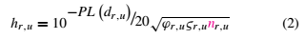
Specifically ϕr,u, ςr,u and r,u represent the antenna gain, shadowing and small-scale fading between RRH and UE,respectively. According to [25], RRHs cooperatively serve UE u through joint beamforming. In this way, the signal-to-interference-plus-noise ratio (SINR) of the UE u at time slot t, γu(t) is written as [25]
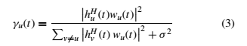
where h
u(t) = [h1,u, h2,u, . . . , hR,u]T and each component hr,u represents the channel gain between RRH r and UE u at time slot t; similarly wu(t) = [w1,u, w2,u, . . . , wR,u]^{T} is the weighted vector and each component of wr,u represents the beamforming weight between RRH r and UE u at time slot t. σ2 represents the background noise. The Shannon capacity for UE u at time slot t, Cu(t) can be calculated as [25]
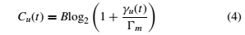
where B is the transmission bandwidth and Ʈm denotes the realistic capacity gap depending on the modulation scheme
3.2.2 Cloud Components

- Base Band Unit Pool
BBU pool consists of multiple BBUs in a form of a cloud, each capable to serve many RRHs. BBUs can be located at Central Office (CO) or Data Centers (DCs) of system.BBUs operate as virtual base stations which comprise of parts that process and schedule the incoming signals from different RRHs and optimizing radio resource allocation [8]. BBUs are responsible for functions from layer 1 to layer 3 depending on functional split between the BBUs and RRHs that used in level of C-RAN architecture [6, 31, 32].
Based on data traffic demand and time varying environment, the signal processing radio resources can be fully shared among different BBUs in the BBU pool. The BBU pool is connected by optical fire to RRHs using Radio over Fiber (RoF) technology. In term of power consumption in the BBU pool, the power consumption model for the BBU pool is calculated as a sum of the active BBUs. Computing resources and processing of the BBU can be measured in by Million Operations per Time-Slot (MOPTS) [33] or Giga Operations Per Second (GOPS) [34] translated into power figures. Many components and functions in
BBU have significant effect in power consumption calculation such as the frequency and time domain processing, central processing units (CPU), Forward Error Correction (FEC) and processing related to CPRI [35].

- Remote Radio Head
RRH is located at the cell site, it provides the wireless signal coverage for the cell site area and comprises of Analogue to Digital Conversion (ADC) and Digital to Analogue Conversion (DCA), Power Amplifier (PA), antennas system, interface adaptation, voltage suppliers and Low Noise Amplifier (LNA) as shown in Fig. 2.5. By moving most of the baseband processing from cell site to BBU pool to reduce both CAPEX and OPEX, which allows a more optimized energy consumption as well as less complexity and of course lowers their price.
Therefore, RRH can significantly help cellular network operators to resolve performance, cost, and efficiency challenges when deploying new base stations in 5G networks. Moreover, RRHs distributed in certain areas such as urban areas with high traffic loads offer efficient cost. They are located at the cell sites and used to transmit the RF signals to users and forward the baseband signals from the users to the BBU pool [6, 36].
Each RRH can be either active (transmitting) or inactive (sleep mode). Active RRHs consume both static power (for base operations) and dynamic power (depending on traffic load). The total energy consumption is a function of the number of active RRHs and the load they carry.

- Fronthaul Network
It can be defied as a connection between RRHs and BBUs to provide low latency and high capacity [28, 37]. C-RAN fronthaul is realized by different technologies such as wireless, and wire represented by optical fire networks. Generally, Wireless fronthaul link are cheaper and faster to deploy than optical fiber fronthaul links. Wireless fronthaul typically operates on the licensed spectrum. Wireless operates with carrier frequencies 5-40GHz. However, they can provide only a few hundred Mbps of data rates due to the limitation of bandwidth at these frequencies [6].Therefore, optical fire network is considered fronthaul link for the next generation of the cellular network to provide the data rate requirements [38, 39]. By using the optical fire fronthaul link, two different protocols can be used; CPRI [30] and OBSAI [29]. However, many operators and cellular companies face difficulty to deploy new optical network fronthaul link for the next generation.
Therefore, they seem more economy to use the infrastructure of optical fiber as a fronthaul for the next generation. The Radio over fiber (RoF) is a technology of integration of optical fiber and wireless access network where two type of RoF candidate to use in C-RAN, Digital (D-RoF) [35] and Analog (A-RoF) [40], which are compatible with CPRI and OBSAI protocols.

3.3 Proposed model

For the current work, an Orchestra Server (OS) is proposed as a server in the BBU pool to support the C-RAN architecture in terms of energy management and self-organization, as shown in Fig. 3.1. The OS hosts a proposed algorithm to find the proper network configuration setting dynamically. It recognizes the network status and instantaneous data traffic demand for each RRH to produce a decision to switch to make reconfiguration of the BBUs-RRHs. An internal switch in Layer-2, behind the BBU pool, is responsible for redirecting traffic from overloaded BBUs to others. That is, this switch response to the OS commands is to reduce the number of BBUs in the context of energy management and saving energy. However, the switching system is considered a significant challenge in C-RAN architecture.
The main challenges and possible solutions for fronthaul reconfiguration in C-RAN are explained in [79]. Moreover, this architecture consists a set of RRHs H: {RRHi, i =1, 2... H}, where H denotes the number of RRHs which are connected with high speed optical fibre fronthaul links to the associated BBUs in BBU pool. Generally, optical fires are the candidates to use in the now and next generation of cellular networks to meet the requirements of data rate demand [5].Furthermore, there is a set of BBUs in the BBU pool M : {Mj , j = 1 , 2 , ..., M}, where M is the number of BBUs in BBU pool for processing the baseband signals of the RRHs. In this architecture, virtualization technology is used, with the BBUs’ functions being installed as software on the servers. A set of users served by RRHi can be represented as U :{ Uu, u = 1, 2... U}, where U denotes their number.
In this work, it is proposed that the user can be processed either by its BBU or other BBUs to achieve load balancing and save energy in the BBU pool. Each RRH in C-RAN architecture is associated to a BBU in the BBU pool to perform the PHYcell functions of RRHs. An OS in BBU pool decides to which BBU a newly arriving user is assigned to. In the case of overload or want to achieve energy saving, the OS allows for the reallocation of a user to a different BBU.
In this architecture, the Optical Line Terminal (OLT) is co-located with the BBU pool and Optical Network Units (ONUs) are co-located with the RRHs at cell sites. In the BBU pool, each BBU is associated with one Line Card (LC), and provides baseband processing functions for all the associated RRHs (one BBU can serve multiple RRHs).In addition, Electronic Smart Switch (ESS) is proposed to be between the BBU pool and OLT to convert the traffic load from the BBUs to the correct LC after switching off a specified number of BBUs under load balancing technology. The ESS is designed to support the dynamic reconfiguration concept for the system which is demonstrated by OS.The ESS routes the traffic load from the BBUs to the LC by Radio Frequencies (RFs) generated by BBUs and each RF is specified to RRH, where one wavelength can carry multi RFs by using Sub-Carrier-Multiplexing (SCM) techniques [79]. Moreover, the RRHs can separate the undesirable frequencies by filters. By using ESS, the system can be a reconfiguration as one to one, one to many, many to many, and many to one.
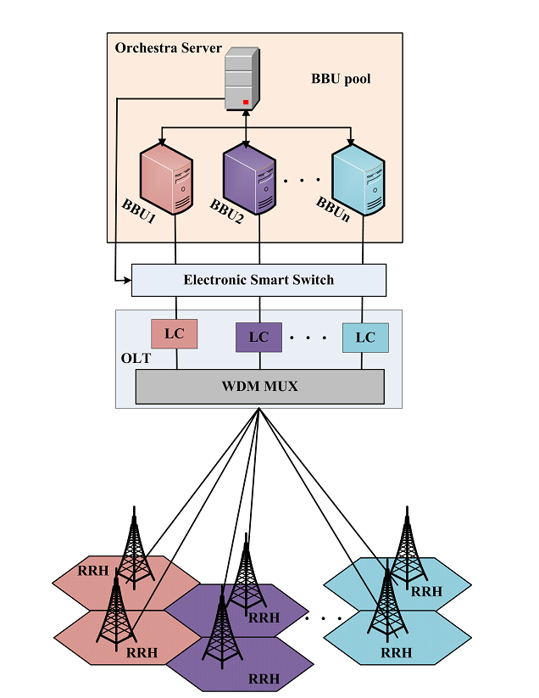

3.4 Resources computation of the proposed model
In the proposed model, knowing the computing resource per user U_{u} in RRHi is essential in order to calculate the energy consumption model for the C-RAN architecture. The baseband processing procedure of each RRH in the BBUs is measured in Giga Operation per Second (GOPS) [34]. Each BBU has maximum capacity G GOPS. eq. 3.1 describes the fraction of Resource Blocks (RBs) allocated to user U_{u} by RRH_{i} [80]:
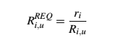 (3.1)
where r_{i} is the data rate demand of user U_{u}, R_{i},_{u} is the achievable data rate for user u when it is associated with RRH_{i} and Ri represents load of RRHi. To obtain R_{i,u}, the Signal to Noise Ratio (SNR) of user u associated with RRHi can model as follows:
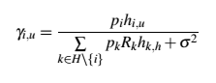 (3.2)

where hi,u is the channel gain between RRHi and user Uu, pi is wireless transmission power of RRHi, and σ2 represents average noise power. Based on the Shannon capacity theorem, R_{i,u} can be calculated as follows:
R _{i, u} = Wlog₂ (1 + γ_{i, u}) (3.3)
The computer resource load of RRHi at the BBUj is obtained by summing the resource usage fractions over all the users in RRHi, which is represented as follows:
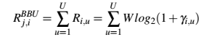 (3.4)
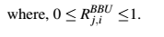

3.5 Power consumption model of the proposed model
The proposed power consumption of C-RAN is divided into three separate parts: remote radio heads power consumption, fronthaul power consumption and BBU pool power consumption.
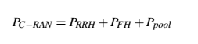 (3.5)
3.5.1 RRH Power Consumption Model
The RRH consists of RF and PA that scale linearly with the number of antennas. The power
consumption for the radio part is calculated as [77]:
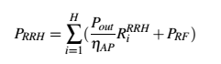 (3.6)
R_{i} ^{RHH} represents the computing resource load of RRHi. The P_{out} represents the output power
of RF per transmitted antenna. P_{RF} depends on the number of antennas, whereas H denotes
the number of RRHs in the network.
Considering the 1.pr, active: consumed power of active RRH; 2.pr, trans: transmission power due to power amplifier; (3) pr,switch: switching power of RRH; and (4) pr,sleep: consumed power of sleep RRH. Let M, N and S denote the set of active, sleep and mode-transition RRHs, respectively. Then, the power consumption can be expressed as
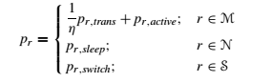
where Pr, trans = $Σ$_{r∈M} Σ_{u∈U} lw_{r, u} l² indicates the transmission power of RRH r and η is a constant indicating the drain efficiency of the power and w_{r,u} represents the beamforming weight between RRH r and UE u at time slot t.The total power P_{total} of RRH is updated at time slot t is expressed as [25]:
P_{total} (t) = $\sum_{rϵM(t)}{ }\sum_{uϵu(t)}{ }\frac{1}{ŋ}$|w_{r, u}|² +$\sum_{rϵM(t)}{Pr,active}$ +$\sum_{rϵN(t)}{Pr,sleep}$ + $\sum_{rϵS(t)}{Pr,switch}$
3.5.2 Fronthaul Power Consumption Model
Considering PON front-haul network, fig 2.5, where it's Optical Network Units (ONUs) implemented in a sleep mode, but the Optical Line Terminal (OLT) is always ON. Thus, power consumed in the front-haul network is defined based on [63] is given by:
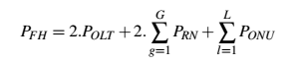 (3.7)
For more elaborate
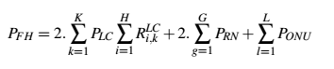 (3.8)

3.5.3 BBU Pool Power Consumption Model
The power consumption at each BBU is composed of two parts: a static power consumption Pstat caused by the procedures (e.g. paging procedures and broadcasting) and a dynamic power consumption Pdyn that depends on the amount of processing load at the BBU.
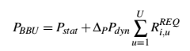 (3.9)
where, ∆P represents the linear power model tangent. Generally, the components of dynamic power consumption in a server are the processor PCPU, memory PMEM and hard disk PIO and these have dynamic power Pdyn of about 58%, 28% and 14%, respectively [85]. The power is presented as follows:
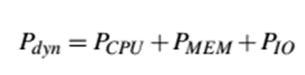 (3.10)
where, PCPU, PMEM and PIO, respectively, represent power consumed by the processor, memory and hard disk for each BBU. However, by substituting equation 3.10 into equation 3.9 becomes:
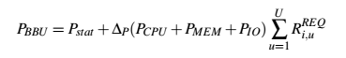 (3.11)
Depending on the EARTH model and the proposed assumption, the power consumption of the BBU pool can be calculated. The total processing power used by the BBU-pool measured in GOPS is:
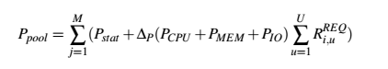 (3.12)

3.6 Problem formation of the proposed model
3.6.1 Problem Formulation of BBU Pool
The virtualization reduces the total power consumption, as each vBBU can be implemented in the physical BBU server through software. However, it is important to optimize the system by reducing the number of active BBU servers that work with low load. This process is performed by transferring their load to others with respect to the available capacity and thus, shutting them down. The problem of optimizing is formulated as shown in equation (3.13) and it can be solved by using Linear Integer Programming (LIP):
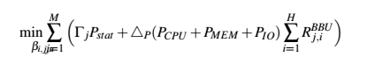 (3.13)
Subject to
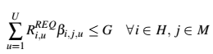 (3.14)
, 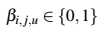 (3.15)
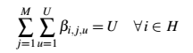 (3.16)
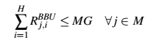 (3.17)
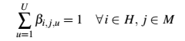 (3.18)
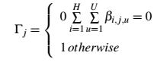 (3.19)
in equation 3.13 can be defined as a computing resource at BBUj that is used by RRHi in GOPS. 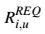represents a computing resource requirement for user Uu that is served by RRHi. BBUj is limited by its processing capacities G, as shown in equation (3.14). The indicator βi , j ,u = 1 when the user Uu of RRHi is processed by BBUj and βi , j ,u = 0, otherwise, where, βi,j,u=1 is used to minimise the number of BBUs that are illustrated in equation (3.15).Equation (3.16) ensures that the U users for RRHi can be processed by either a single one or multiple BBUs J. Equation (3.17) indicates that the total processing capacity of the BBU pool is higher than the total computing requirements for all the RRHs. Constraint in equation (3.18) ensures that each user Uu is assigned to one BBUj. Finally, Γ j indicates the status of
BBUj, whether it is ON or OFF, as shown in equation (3.19).
3.6.2 Problem Formulation of Fronthaul
The proposed model minimises the total number of used LCs wavelengths.
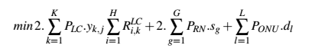 (3.20)
Subject to:
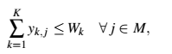 (3.21)
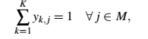 (3.22)
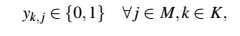 (3.23)
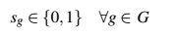 (3.24)
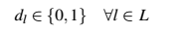 (3.25)
Where, 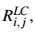 computing the resource load of BBU j at LC k and yk , j = 1, if BBU j is served by the LC k , otherwise 0, as shown in equation (3.23). The LCs are limited by the wavelength capacities Wk shown in equation (3.21). The constraint in equation (3.22) ensures that each BBU j is assigned to one LC. S_{g} and d_{l} are Boolean variables indicating weather gth and lth of RN and ONU, respectively, are active or in sleep mode, as shown in equations (3.24) and (3.25), respectively.

3.6.3 Problem formulation of RRH
For RRH selection in each time slot t. Given the set of active RRHs M(t) problem (6) is reduced to slot-by-slot optimization
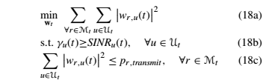
Where Constraint (18b) implies that the demand of user u is guaranteed

3.7 Deep reinforcement learning framework and implementation
In this work, we employ the Deep Deterministic Policy Gradient (DDPG) algorithm to learn continuous control policies for energy management in a 5G C-RAN. DDPG utilizes two function approximations: an Actor network for the policy π(s) and a Critic network for the action-value function Q(s,a). Both networks are implemented as deep neural networks and trained end-to-end via interaction with the C-RAN environment.
3.7.1. Overview of the DDPG Algorithm
To cope with the limitations of traditional reinforcement learning methods in continuous action spaces, the DDPG algorithm combines the expressive capabilities of deep learning with the optimization strategies of policy gradient methods, achieving policy optimization through the actor–critic structure.
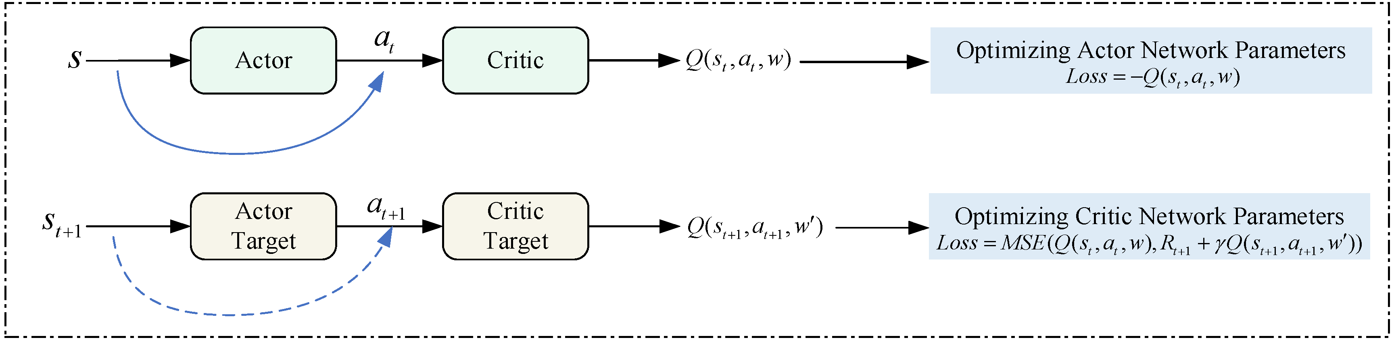
Figure 3. DDPG algorithm block diagram

The framework of the DDPG algorithm is shown in Figure 3. The actor and critic training networks are used to learn to select and evaluate actions, respectively. The actor target network provides stable target strategies for the actor training network, while the critic target network provides stable Q-value for the critic training network and is updated synchronously regularly.
The action value function Q_{π} evaluates the expected cumulative reward obtained by taking action a_{t} in state s_{t}. The Bellman expectation equation for the Q-value under policy π is expressed as follows:
Q_{π} (s_{t},a_{t}) =E [R_{t+1}+γ⋅∑_{a′} πa′s_{t+1} Q_{π}s_{t+1}, a′S_{t}=s_{t}, A_{t}=a_{t}] (20)
where R_{t+1} is the reward obtained after taking action at in the state s_{t}, s_{t+1} is the next state, a′ is the possible action to be taken in the next action, and πa′s_{t+1} is the probability of the policy to take the action a′ in the next state.
The optimal policy is determined by maximizing the Q-value:
π∗=arg_{π}maxQ_{π}s_{t},a_{t} (21)
To directly evaluate the current state and action without considering the influence of policy π, the optimal action value function Q∗s_{t},a_{t} is introduced. For the optimal Q-value function, the Bellman optimality equation is expressed as follows:
Q∗s_{t},a_{t}=ER_{t+1} + γ⋅max_{a′}Q∗s_{t+1}, a′S_{t}=s_{t}, A_{t}=a_{t} (22)
The Q∗s_{t},a_{t} function is updated as follows:
Q∗s_{t},a_{t}←1−αQ∗s_{t},a_{t}+α⋅R_{t+1}+γ⋅max_{a′}Qs_{t+1}, a′ (23)
where α is the learning rate of the Q∗s_{t},a_{t} function update.

3.7.2. Neural Network Structure and Training
3.7.2.1. Neural Network Structure
- Actor Network: The Actor network maps the current state of the C-RAN to deterministic continuous actions, such as transmit power levels, bandwidth allocation, and RRH sleep/wake decisions. The architecture consists of:
  - Input Layer: State vector comprising per-RRH traffic load, queue length, channel state information, CPU utilization of BBU pool, and system-wide energy consumption.
  - Hidden Layers: Two fully connected layers with 256 and 128 neurons respectively, using ReLU activation to capture non-linear relationships between network conditions and control actions.
  - Output Layer: A dense layer with tanh activation, scaled to the physical range of each action variable. This ensures outputs remain within feasible power and bandwidth limits.

- Critic Network: The Critic network evaluates the quality of state-action pairs to guide policy improvement. It adopts a concatenated input structure:
  - State Path: The state vector passes through two dense layers with 256 and 128 neurons, ReLU activation.
  - Action Path: The action vector is processed by a separate dense layer with 128 neurons.
  - Fusion and Output: The outputs are concatenated and fed into two additional dense layers before producing a single Q-value with linear activation.

3.7.2.2. Training Procedure
- Optimization Algorithm: Both Actor and Critic networks are optimized using Adam. The learning rates are set to 1×10⁻⁴ for the Actor and 1×10⁻³ for the Critic to balance policy updates with value estimation. Adam’s adaptive moment estimation reduces the need for manual learning rate tuning across heterogeneous C-RAN states.
- Experience Replay and Target Networks: A replay buffer of size 1×10⁶ transitions stores past experiences (s, a, r, s′). Mini-batches are sampled uniformly to break temporal correlation. Separate target networks for Actor and Critic are maintained and updated via soft updates with τ = 0.001 to stabilize learning.

- Reward Design: The reward function is designed to balance energy consumption and quality of service:
r_{t} = - (α·E_{total(t)} + β·L_{avg(t)} + ϒ·V_{QoS(t)} ),

where E_{total(t)} is total energy consumption, L_{avg(t)} is average packet latency, and V_{QoS(t)} denotes QoS violations. Weights α, β, γ are tuned so that energy minimization does not compromise latency and reliability constraints.

- Exploration and Regularization: Ornstein-Uhlenbeck noise is added to the Actor’s output during training to ensure exploration in the continuous action space. Batch normalization is applied to hidden layers to mitigate internal covariate shift and accelerate convergence.

3.7.3 DDPG Algorithm Elements and Processes
3.7.3.1. Core Algorithm Elements
- Actor Network – Deterministic Policy: The actor μ (s|θ^μ) approximates a deterministic policy that maps the current C-RAN state s to a specific action a. Actions include transmit power levels, bandwidth allocation, and RRH activation states. The actor is denoted by θ^μ and updated via policy gradient ascent to maximize the expected return.
- Critic Network – Action-Value Function: The critic Q(s, a|θ^Q) estimates the expected cumulative reward for taking action a in state s and following the policy thereafter. It provides a gradient signal to the actor and is denoted by θ^Q. The critic is trained to minimize the Bellman error using observed transitions.
- Target Networks: To improve training stability, DDPG maintains slowly updated target networks μ′(s|θ^μ′) and Q′(s, a|θ^Q′). These target networks are soft-updated using: θ′←τθ +(1−τ)θ′ with τ ≪ 1, typically 0.001.
- Experience Replay Buffer: An off-policy replay buffer stores transitions ( s(t), a(t), r(t), s(t+1) ) collected by interacting with the C-RAN environment. Random mini-batch sampling from the buffer decorrelates consecutive samples and improves data efficiency.

3.7.3.2. Algorithm Processes
Action Selection and Exploration: At each time step, the actor selects an action based on the current state. To enable exploration in the deterministic policy, Ornstein-Uhlenbeck noise N_{t} is added:
a_{t}​=μ (s_{t}​∣θ^{μ})+N_{t}. ​
The noise is temporally correlated to facilitate efficient exploration in control problems with inertia, such as power control.
Critic Update: A mini-batch of transitions is sampled from the replay buffer. The target Q-value is computed using the target networks:
y_{t}​=r_{t}​+γQ′(s_{t+1}​,μ′(s_{t+1}​∣θ^{μ′})∣θ^{Q′})
The critic is updated by minimizing the mean squared Bellman error:
L(θ^{Q})=$\frac{1}{N}$∑_{i}(y_{i}​−Q(s_{i}​,a_{i}​∣θ^{Q}))²
Actor Update: The actor is updated using the sampled policy gradient derived from the critic:
∇_{θμ}​J≈$\frac{1}{N}$∑_{i}​∇_{a}​Q(s_{i}​,a∣θ^{Q})​|_{a=μ(si​)}​∇_{θ}^{μ}​μ(s_{i}​∣θ^{μ})
This directs the actor toward actions that yield higher estimated Q-values.
Target Network Update: After each learning step, target networks are updated via soft update to track the learned networks slowly, ensuring stable bootstrapping.

Algorithm: Deep Deterministic Policy Gradient
1. Inputs: initial policy parameters θ,Q-function parameters and replay buffer
2.

CHAPTER FOUR: SIMULATION RESULTS, PERFORMANCE EVALUATION AND DISCUSSION

CHAPTER FIVE: CONCLUSION AND FUTURE WORK

REFERENCES
[1] O. Vierimaa et al., “Cost modeling of cloud-based radio access network,”
https://aaltodoc.aalto.fi, 2017.
[2] G. Liu and D. Jiang, “5g: Vision and requirements for mobile communication system
towards year 2020,” Chinese Journal of Engineering, vol. 2016.
[3] A. Gupta and R. K. Jha, “A survey of 5g network: Architecture and emerging technologies,” IEEE access, vol. 3, pp. 1206–1232, 2015.
[5] C. Kullin and D. Ran, “C-ran the road towards green ran,” China Mobile Research
Institute, White Paper, 2011.
[6] M. Peng, C. Wang, V. Lau, and H. V. Poor, “Fronthaul-constrained cloud radio access
networks: Insights and challenges,” IEEE Wireless Communications, vol. 22, no. 2,
pp. 152–160, 2015.
[8] A. Checko, H. L. Christiansen, Y. Yan, L. Scolari, G. Kardaras, M. S. Berger, and
L. Dittmann, “Cloud ran for mobile networks-a technology overview,” IEEE Communications surveys & tutorials, vol. 17, no. 1, pp. 405–426, 2015.
[12] V.-G. Nguyen and Y. Kim, “Proposal and evaluation of sdn-based mobile packet core
networks,” EURASIP Journal on Wireless Communications and Networking, vol. 2015,
no. 1, p. 172, 2015
[21] C. Mobile, “C-ran: the road towards green ran,” White Paper, ver, vol. 2, 2011
[26] R. Bolla, R. Bruschi, and P. Lago, “The hidden cost of network low power idle,” in
Communications (ICC), 2013 IEEE International Conference on. IEEE, 2013, pp.
4148–4153.
[28] P. McClusky and J. L. Schroeder, “Fiber-to-the-antenna: Benefis and protection
requirements,” in Telecommunications Energy Conference (INTELEC), 2012 IEEE
34th International. IEEE, 2012, pp. 1–6.
[67] Y. Sun, J. Wang, F. Sun, and Z. Zhang, “Local altruistic coalition formation game
for spectrum sharing and interference management in hyper-dense cloud-rans,” IET
Communications, vol. 10, no. 15, pp. 1914–1921, 2016.
[68] S. Jeong, O. Simeone, A. Haimovich, and J. Kang, “Positioning via direct localisation
in c-ran systems,” IET communications, vol. 10, no. 16, pp. 2238–2244, 2016.
[69] Z. Fei, C. Xing, N. Li, D. Zhu, and M. Lei, “Leakage-based distributed minimum mean-square error beamforming for relay-assisted cloud radio access networks,” IET Communications, vol. 8, no. 11, pp. 1883–1891, 2014.
[11*] Y. Lin, L. Shao, Z. Zhu, Q. Wang, and R. K. Sabhikhi, “Wireless network cloud:
Architecture and system requirements,” tech. rep., International Business Machines, 2010.
[25*] China Mobile Research Institute, “C-RAN The Road Towards Green RAN,”
tech. rep., China Mobile, 2011

https://www.mdpi.com/2076-3417/14/24/12014

